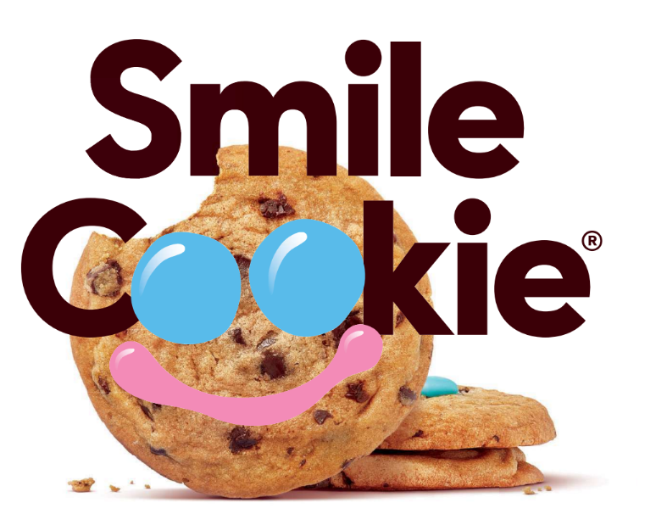
Pre-Order Form
From April 27-May 3, Tim Hortons Restaurant Owners will be supporting nearly 700 local charities, hospitals and community programs across Canada. Guests who purchase a freshly baked Smile Cookie will be donating to these great causes with 100% of proceeds being donated! To pre-order Tim Hortons Smile Cookies, complete this form and submit it to your nearest participating Tim Hortons Restaurant no less than 48 hours of your specified pick up date & time. Or visit the Tim Hortons app, Uber Eats, Door Dash or Skip the Dishes to see if your Smile Cookies can be delivered.

Number of Cookies: |  | 12 Cookies per box

Your Name:
Address:
 | Telephone: | ( )
 | Email:

Pick Up Date: |  | Pick Up Time:

Thank you for your support!

